EMPLOYEE RAISE ISSUE – RECORD PRODUCER & SERVICE PORTAL INTEGRATION
PHASE 7: Testing and Validation

1. Introduction
This phase validates the complete Employee Raise Issue solution from the employee-facing Service Portal to the backend ServiceNow table.

2. Objective
To perform end-to-end testing and confirm that the portal, widgets, Record Producer, UI Policies, dependency, and field restrictions work as configured.

3. Testing URL
Open the configured employee_request portal URL. Example format: https://<instance>.service-now.com/employee_request

4. Testing Procedure
1. Open the Employee Requesting Portal.
2. Verify that the portal loads successfully.
3. Confirm that the configured image/logo and portal components are displayed.
4. Scroll down and verify that the created widgets are visible.
5. Move the cursor over the widgets and verify the floating/hover behavior.
6. Click the Raise Ticket or equivalent request link.
7. Verify that the Raise Employee Issue Record Producer opens.
8. Fill in the requester and issue details.
9. Select a Category and verify the appropriate Subcategory choices.
10. Set State to New and verify that Short description becomes mandatory.
11. Verify that Number is read-only.
12. Submit the Record Producer.
13. Open the Employee Raise Issue table and verify that a backend record was created.
14. Confirm that the submitted values are stored correctly.

5. Validation Checklist
- Service Portal opens successfully.
- Configured image/logo is displayed.
- Custom widgets are visible.
- Widget hover/floating effect works.
- Record Producer opens from the portal.
- Category–Subcategory dependency works correctly.
- Short description becomes mandatory when State is New.
- Number field is read-only.
- Record Producer submission creates a backend Employee Raise Issue record.
- Submitted information is stored correctly.
Employee Requesting Portal homepage
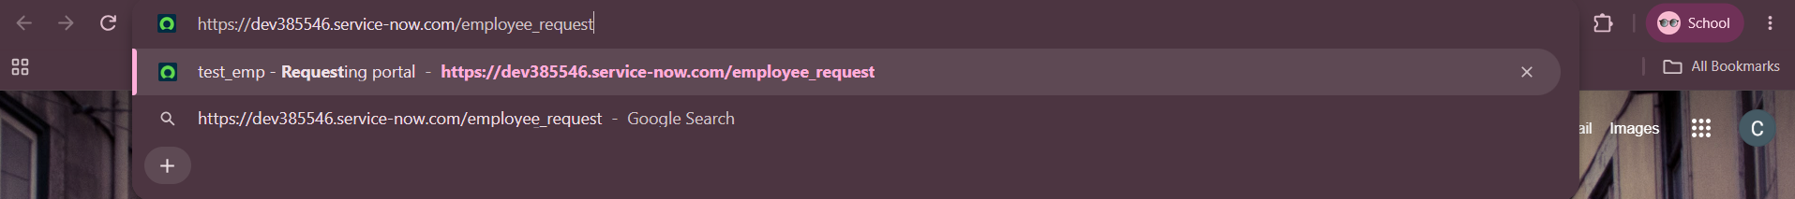
Custom widgets displayed on the portal
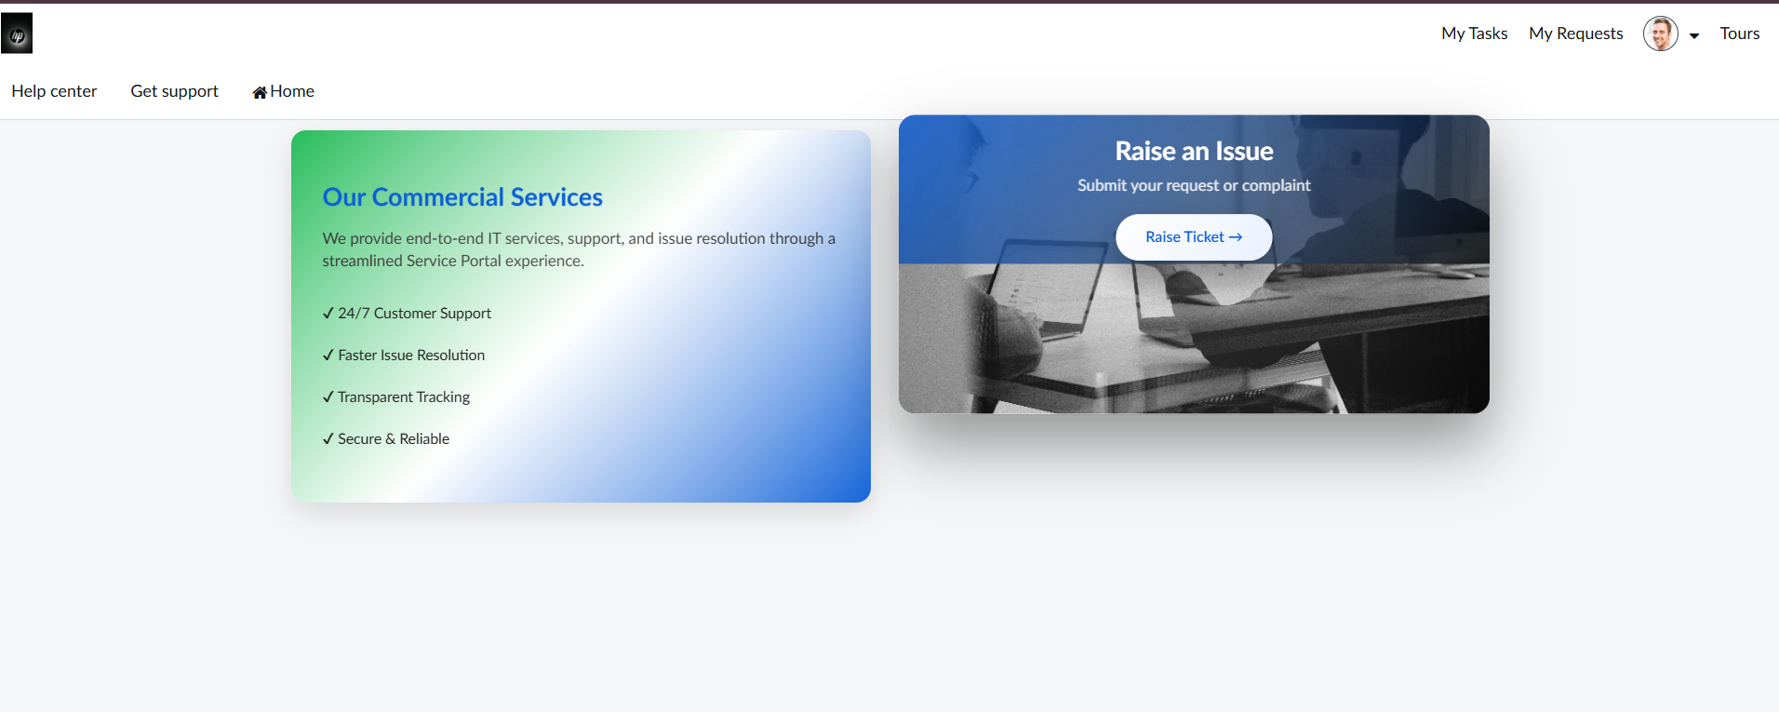
Raise Employee Issue Record Producer
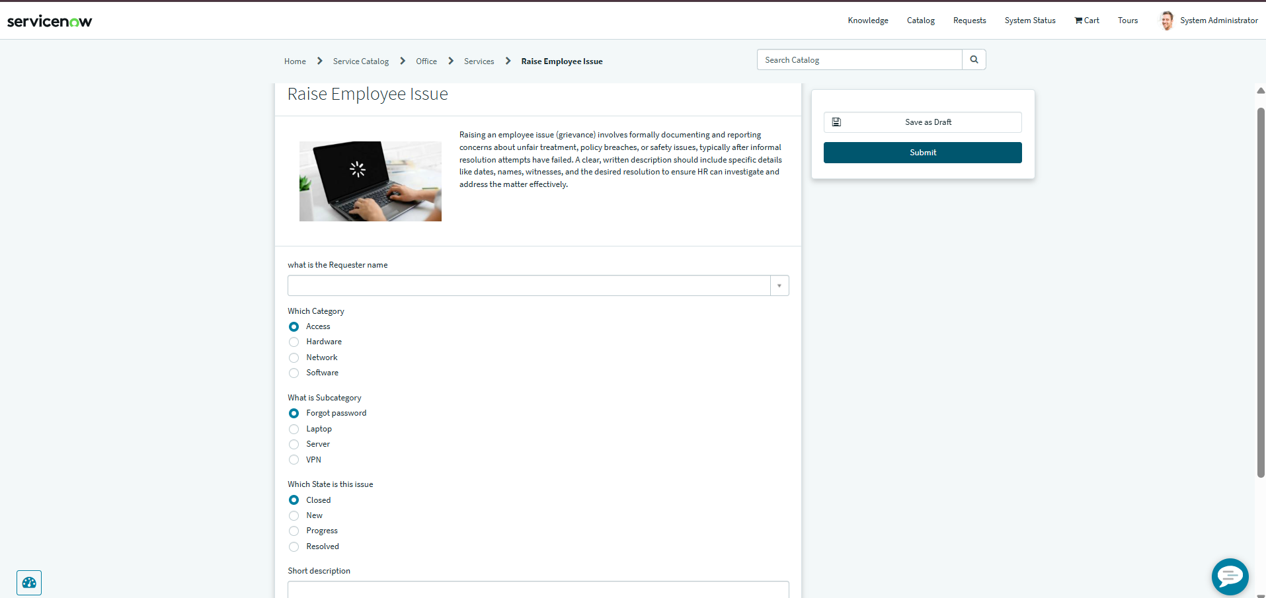
Category and Subcategory behavior
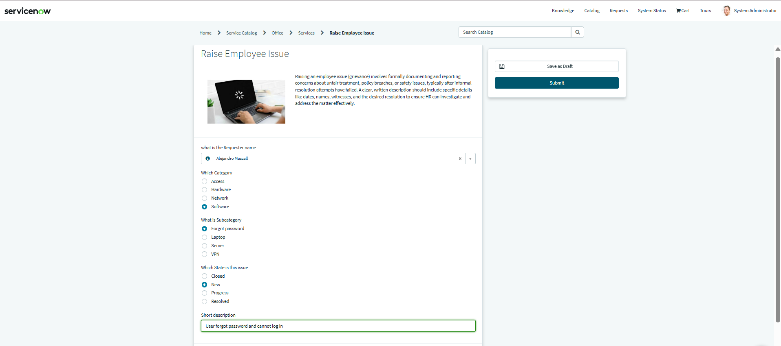
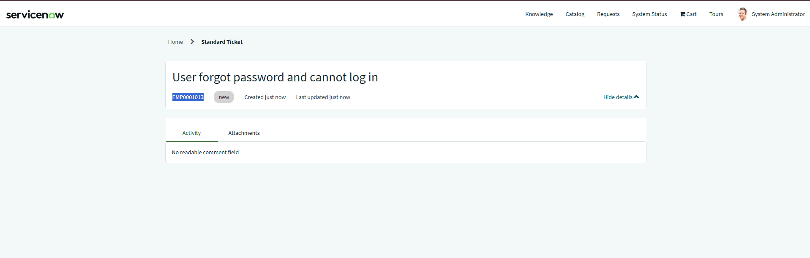
UI Policy behavior on the Employee Raise Issue form
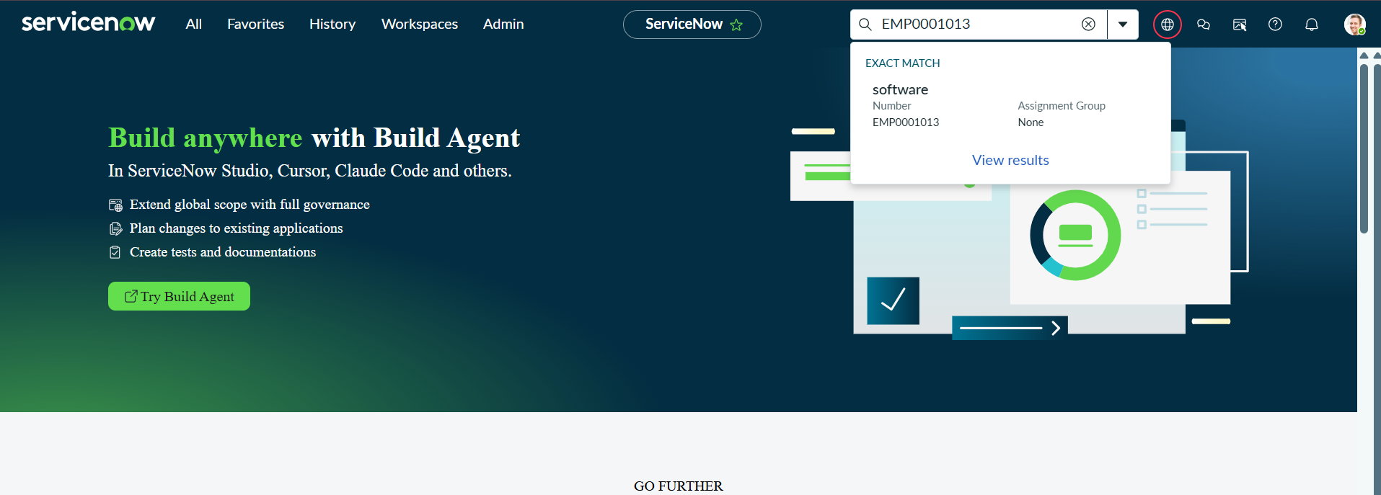

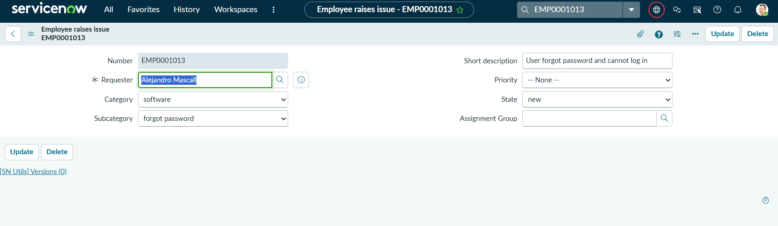
Successfully created Employee Raise Issue record
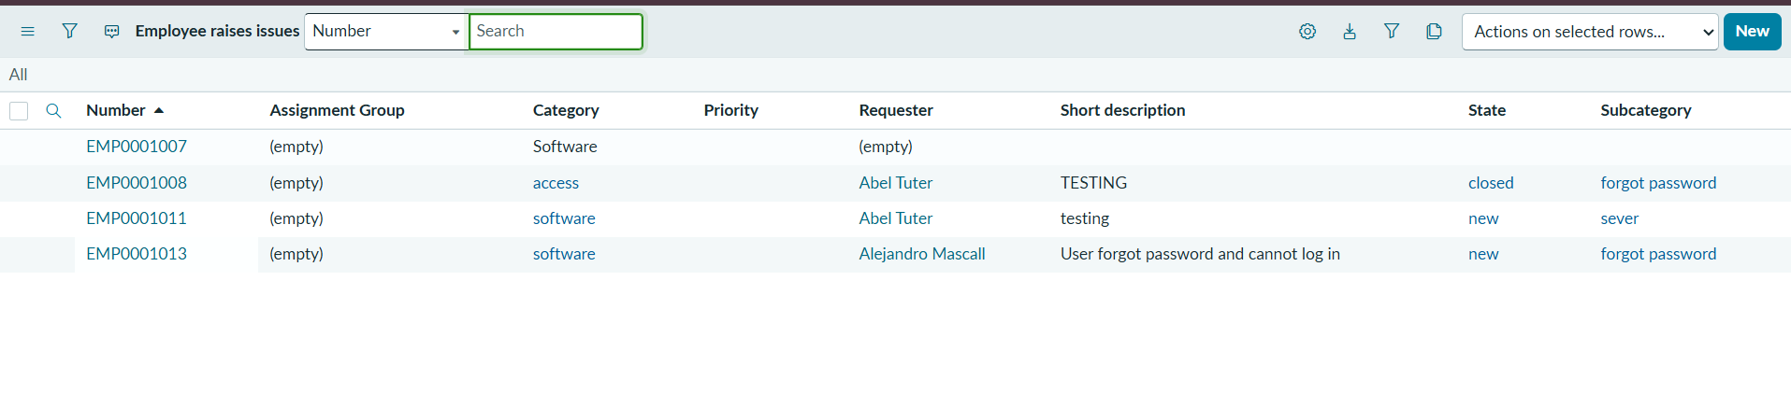

6. Result
End-to-end testing confirms that the major components work together as intended, from employee request submission through backend record creation.

